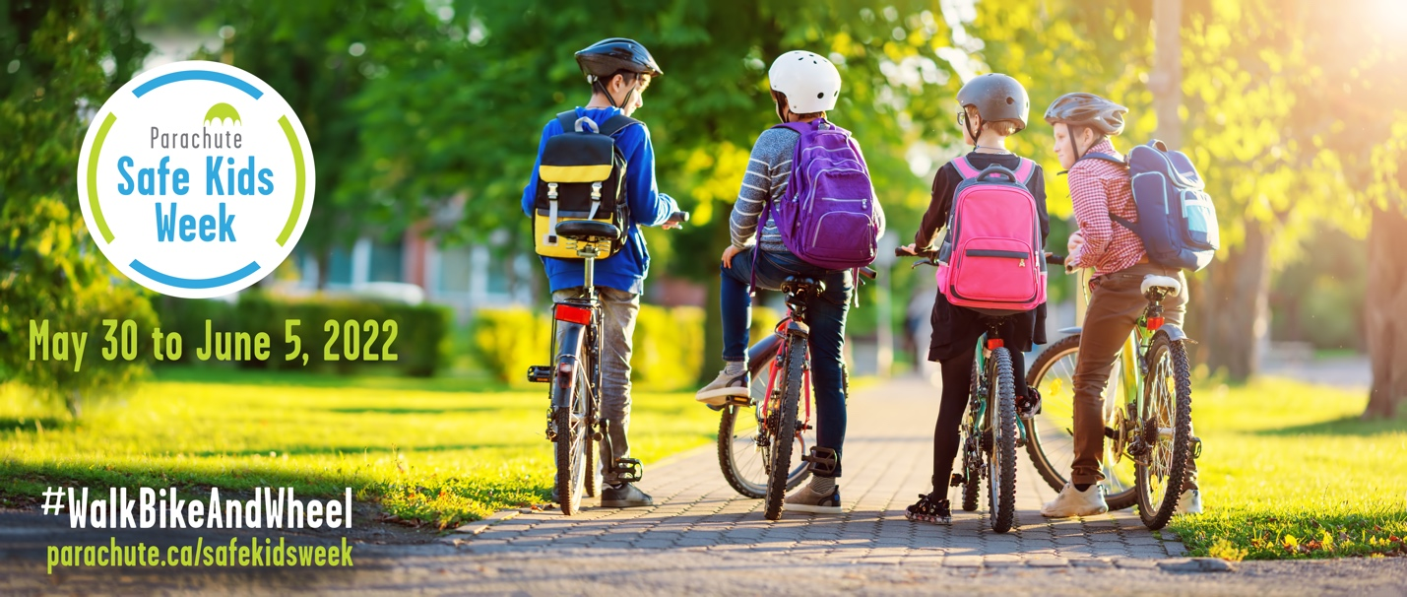
Anything But a Car Day (ABCD)

Event guide

Parachute Safe Kids Week is an annual awareness campaign designed to bring attention to predictable and preventable injuries in children. This year Safe Kids Week focuses on promoting active and safe transportation: #WalkBikeAndWheel.

This year, Parachute encourages schools across Canada to promote walking, biking or wheeling to school by planning an Anything But a Car Day (ABCD). Join us in celebrating Safe Kids Week 2022 and get children excited about using active and safe transportation. Get started!

STEP 1: Form a team and set a date
- Get your principal’s support and form a team with people who are interested in helping organize your ABCD. Get teachers, parents/caregivers and students involved in the planning process. You can also pick a class to help plan and lead the day.

- Pick a date that works for your organization during Parachute Safe Kids Week, which runs from May 30 to June 5, 2022. We suggest picking a day early in the week so that you have the option of moving your event to later in the week if there’s bad weather on your planned ABCD.

STEP 2: Plan a whole school activity
- Get the whole school involved. This can be anything from a school assembly to a walk, bike or wheel around the school. The goal is the have fun and promote active and safe transportation to and from school.

- A great activity is an Active School Bus. An Active School Bus is a group of children walking, biking and wheeling together under the supervision of one or more adult volunteers following a route and schedule. It offers a safe, fun, healthy and environmentally friendly way for kids to get to and from school. The active school bus co-ordinator picks up children at a designated stop and they walk or wheel along a safe, predetermined route to school and in reverse on the way home from school.

- Get the whole school community involved by creating a School Street. The School Streets program temporarily closes the street in front of schools to cars and opens them to students to walk, bike or wheel to and from school. For more details on how your school can do this, see 8 80 Cities School Streets Guidebook by going to https://www.880cities.org/portfolio_page/school-streets-guidebook/.

- For all activities and events, make sure you have an appropriate number of volunteers and teachers for supervision to ensure safety.

- For more information on how to create a successful active and safe transportation event visit https://ontarioactiveschooltravel.ca/steps-to-success-the-5-es/#fivees|1

STEP 3: Promote your active school travel day and activity
- Promote the event in the school newsletter, on social media and during drop off and pick up time. Encourage all students and staff to walk, bike or wheel to school.

- Provide education to parents and caregivers on how to get to school safely. Send them a copy or link to the Active Transportation Safety Tips Sheet that we’ve created for Safe Kids Week 2022. Find the link at parachute.ca/safekidsweek

- For more ideas on how to promote your ABCD, see our Safe Kids Week 2022 social media guide.

STEP 4: Have your Anything But a Car Day
- Give out prizes such as sunglasses or bookmarks to encourage participation. You can download Parachute’s 2V1 helmet-fitting bookmark and print it out.

- Safety is of the utmost importance. Ask students, families, staff and organizers to wear brightly coloured clothing, a reflective safety vest or reflective gear. Also make sure those biking and wheeling are wearing the appropriate gear (e.g., helmet, wrist guards, elbow and knee pads). Safety first!

For more information, visit
parachute.ca/safekidsweek

